Vermeer Technologies (A) and (B)
Institution
Name
Date

Executive Summary
Vermeer Technologies A and B are tech companies that are set up to provide their clients with the latest technology; specifically, the company will be dealing with electronic publishing and online services. The company is headed by Charles H. Ferguson, chairman; Randy Forgaard, CTO; John Mandile CEO; Frank Germano, Jr., VP, Engineering; Peter Amstein Project Leader Tools; Andy Schulert Project Leader Server; Rob Silver Project Leader Documentation; Susan Hiller, Project Leader Quality Assurance; Ed Cuoco Director Product Marketing & Business Development; Manda Schossberger, Office Manager. The company is determined to resolve the issue concerning establishing data sources; they are to come up with an easy-to-use and inexpensive software package that will enable anybody to develop and operate sophisticated Web services-without any programming whatsoever.The Vermeer developers are located in Cambridge office.
Company Description
Vermeer Corporation provides electronic publishing services and online services to their clients. Initially, such services were provided based on a centralized design and used proprietary technology. The services were expensive to develop, and they were also at times incompatible with the rest of the other services. Thus, the organizations that used to procure such services at times they reached a point where they found themselves locked into a limited set of subscriber-customers. Thus, Vermeer Corporation started to solve such issues and to provide the organization with a chance of reaching out to a large number of customers.
Market Analysis
Initially, electronic publishing and online services were provided on a centralized design and employed the use of proprietary technology. These services were very expensive to come up and were also incompatible with other services. The businesses that used these services found themselves been locked into a limited number of customers. Additionally, for the companies to access the services, they had to part with a lot of cash. However, the organizations could have developed their own customized online services. But, they were also going to face challenges such as high operational costs and staff development. In the end, the technologies would result from the organizations into being isolated technologically and also they could provide limited access to the sets of customers. Some of Vermeer's competitors are Adobe, Sausage Software, makers of HotDog, Navisoft and Microsoft. The company also identified some of its potential customers such as New York brokerage firms, commercial banks, online services, and content providers.
Organization and Management
The company is headed by Charles H. Ferguson, chairman; Randy Forgaard, CTO; John Mandile CEO; Frank Germano, Jr., VP, Engineering; Peter Amstein Project Leader Tools; Andy Schulert Project Leader Server; Rob Silver Project Leader Documentation; Susan Hiller, Project Leader Quality Assurance; Ed Cuoco Director Product Marketing & Business Development; Manda Schossberger, Office Manager. Vermeer Technologies A and B are tech companies that are set up to provide its clients with the latest technology; specifically, the company will be dealing with electronic publishing and online services. Thus, Vermeer Corporation started to solve such issues and to provide the organization with a chance of reaching out to a large number of customers.
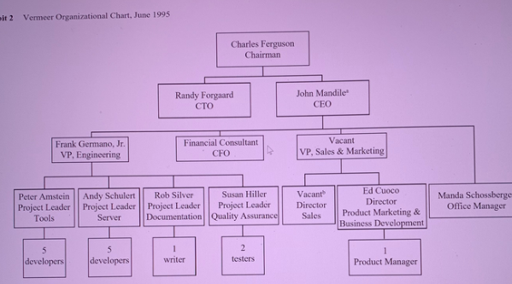
Service or Product
Vermeer Corporation is a firm that was established to provide online services and electronic publishing services. They will come up with a platform that will be based on the World Wide Web where it will be accessible to a wide range of customers. The customers will be able to procure the space to host their information where it will be possible to be accessed worldwide.
Marketing and Sales
The company hired Mandile at a time when it was looking for a person who could steer the marketing force since it was almost launching their product. Mandile made the decision to hire Jay Wright who was to be the Director of Sales; in charge of sales and distribution. Mandile was also concerned with the marketing task, and the company had to draw a marketing budget if it were to make any substantial marketing efforts. The company settled for a marketing budget which amounted to $300 k. Since the company was still young and had little access to financing, it had to come up with such a small marketing budget. Mandile ensured that the marketing plan was executed keenly so that its impact could be felt within the market, and thus he proposed the company to use direct sales agents. Vermeer partnered with internet access providers, content providers, hardware companies, and software companies that were already operating within the market. Finally, Vermeer Co. reached OEM deals with AT & T, Tribune Media Services, and American Internet. The management hoped that the created EOM deals were going to place the company on limelight within the industry market.
Financing Request
The company was young and had limited access to financing. Thus, the co-founders had to part with some money which they had saved in order to finance the activities of the company. Ferguson financed the running of the company during its early life while the development engineers were not paid for their services at first. The company sought a sponsor who could fiancé its activities. The company sought an initial investment that ranged between $500,000 to $ 2 million.
Proposed Equity Structure after First Round of Financing
Owner | % Share-holding
Venture Capitalists | 51
Charles Ferguson | 13
Randy Forgaard | 5
Frank Germano | 4
Other Employees | 27

Financial Projections
Below is the representation of the revenues, gross profit, and net income that was projected at the beginning of the company.
